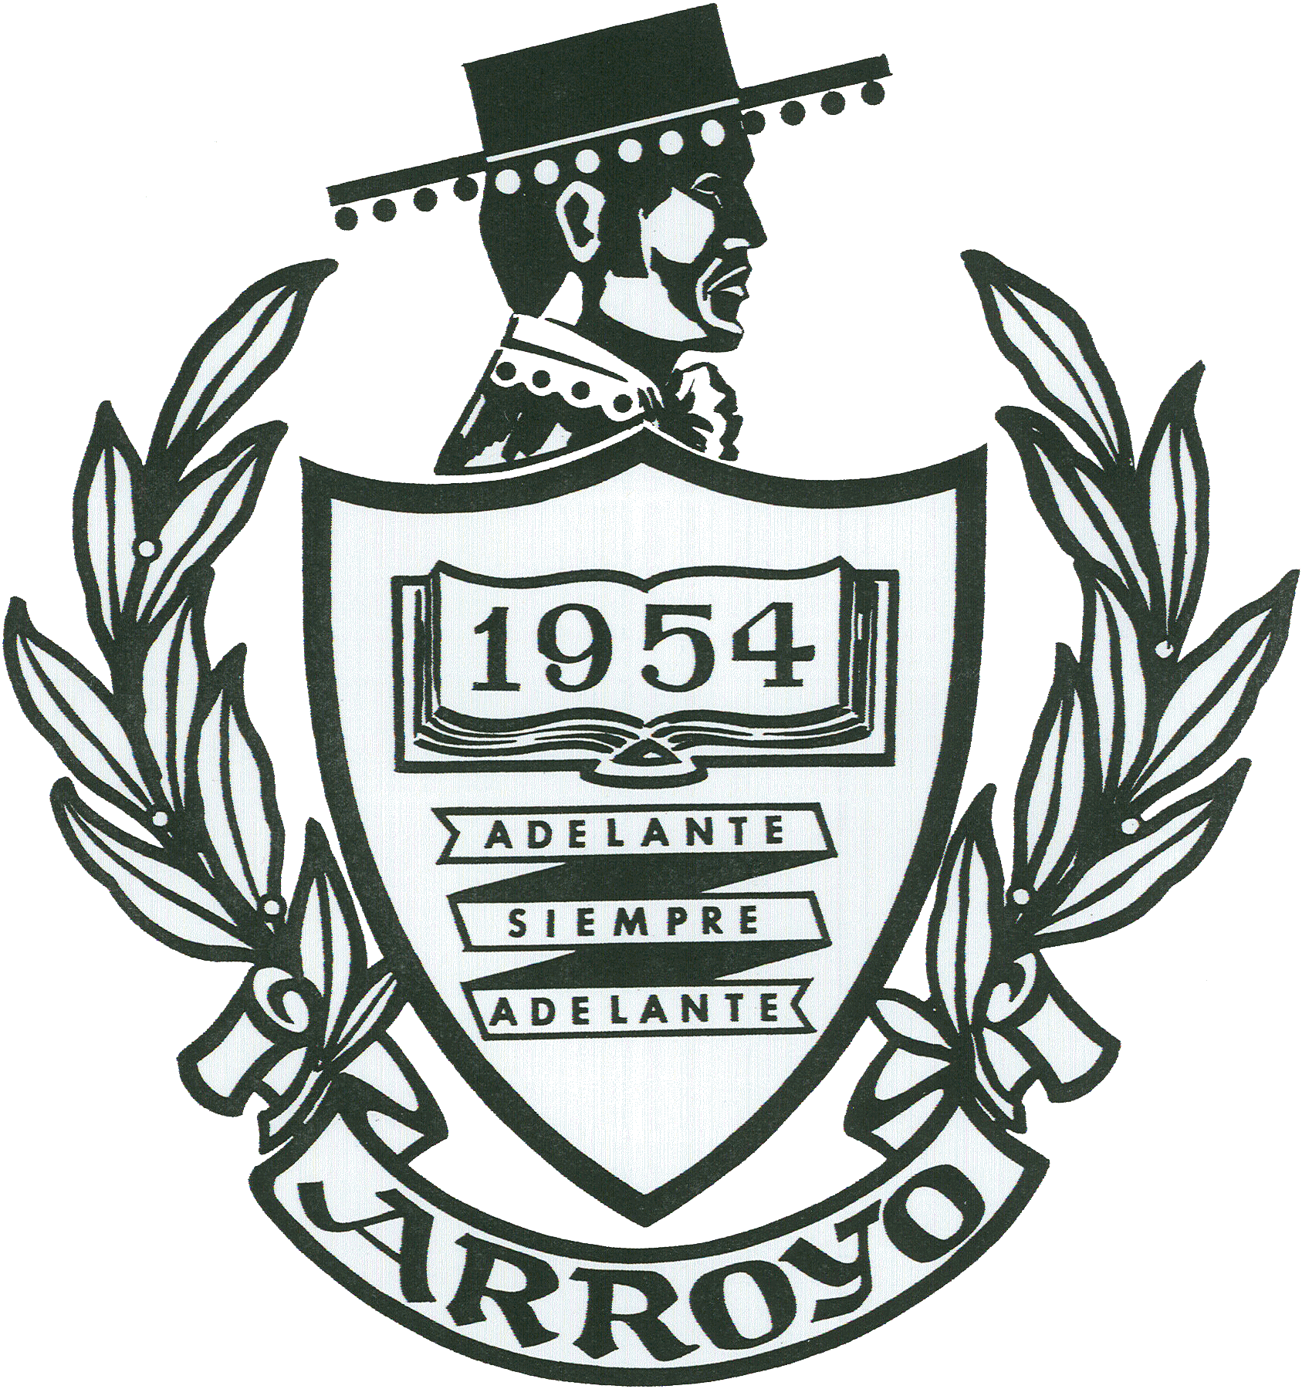

Writing, Art, and Photo Contest
For current Arroyo Students
Sponsored by AHS 2014 Mega Reunion Committee

“What Arroyo Means to Me”

What does Arroyo mean to you? The Arroyo High School 2014 Mega Reunion Committee wants to know. We will be accepting one page essays, art in any form (drawing, painting, ceramics, sewing, etc) and photography. There will be 3 cash prizes in each of the three categories listed above.

- Turn your entry into Ms. Rosiles no later than October 10th
- Entries due NO later than October 10th
- You must pick up your entries from Mrs. Rosiles by October 24th
- Awards will be given out at the Mega Reunion ‘Meet & Greet’ October 18th from 10-2 at Arroyo High School

1st Place $100
2nd Place $50
3rd Place $25

Attach to your entry

Name: ______________________________Grade __________
Entry: Circle One Writing Art Photography

Title of Entry: _______________________________________

